COS125 Assg #10 Name _____________________
Due: Friday 12/1/17
Late: Friday 12/8/17

Create a Word document named A10YourName (use your own name) with answers to Part I questions and the screen shot of program output.

Part I. (20 pts.)

1. (2) Check off which type of members a derived class may access from its base class.

______ public
______ protected
______ private

2. (2) The ____________ operator is used to determine whether a reference variable references an object of a particular class.

a. instanceof b. private
c. super d. typecast

3. (2) Using __________ binding, the Java system determines which method to call, based upon the type of the object referenced by a reference variable.

a. dynamic b. early
c. runtime d. static

4. (2) A base class reference variable may by assigned the address of either a base class object or a derived class object.

a. True
b. False

5. (2) If a derived class inherits from an abstract base class, it must override all abstract methods listed in the base class.

a. True
b. False

Use the following class declarations for the next two questions. Assume each class offers a toString method that returns a String of appropriate data.

public class Vehicle { … }

public class Car extends Vehicle { … }

public class Motorcycle extends Vehicle { … }

public class SUV extends Car { … }

6. (6) Check off all legal statements.

_______ Vehicle v = new Car ( );

_______ Car c = new SUV ( );

_______ Motorcycle m = new Vehicle ( );

_______ Vehicle v = new SUV { … }

_______ Vehicle [ ] va = new Motorcyle [20];

_______ SUV [ ] sa = new Car [20];

7. (2) A dealer creates an array to model the cars, SUVs, and motorcycles on the lot. Write the line of code to instantiate the first array element to a Car object using the default Car constructor.

Vehicle va [ ] = new Vehicle [100];

va[0] = ______________________________________________________________;

8. (2) Given the line of code for Question #7 has been done, what statement is true about the line shown below?

System.out.println (va[0].toString( ));

a. The toString method of the Car class is called.
b. The toString method of the Vehicle class is called.
c. This line generates an error as it cannot be determined which toString method to call.

Part II: (80 pts) This program will give a student a list of textbooks needed for courses as well as a list of related tradebooks of interest to the major.

Name the main program A10YourName.java. Turn in code for all classes in order (Book, Textbook, Tradebook, A10YourName) and upload file to Blackboard Assignment #10 link. Failure to submit files correctly will result minimally in a late 15 point penalty.

1. Design an abstract class Book to model a book at a university book store. Each book contains a title, author, ISBN number, and wholesale price. A default constructor is needed for an empty book. A parameterized constructor is passed arguments. Accessors and mutators for all data members are needed. Abstract method retailPrice returns the retail price.

2. Design a class Textbook derived from Book. A textbook adds a data member for the course associated with the textbook (ex. COS225). The retailPrice method returns a retail price that uses a 10% markup percent (ex. a book with a wholesale price of $100 would have a retail price of $110).
A default constructor is needed for an empty textbook. A parameterized constructor is passed all arguments. Accessor and mutator methods are needed for the new data member.

2. Design a class Tradebook derived from Book. A tradebook adds a data member for the major associated with the tradebook (ex. COS). The retailPrice method returns a retail price that uses a 15% markup percent (ex. a book with a wholesale price of $100 would have a retail price of $115).
A default constructor is needed for an empty tradebook. A parameterized constructor is passed all arguments. Accessor and mutator methods are needed for the new data member.

3. Design a BooklistGenerator class. This class will use an array of Book references to manage books. The array has initial capacity 50. Data file books.txt contains a list of books where the first line indicates the type of book (Textbook or Tradebook). Successive lines list book title, author, ISBN number, and price. The last line of a data set lists either the course (for a textbook) or the major (for a tradebook). Code should work for any input file with unknown number of lines but no more than 50. You may assume all data is valid.

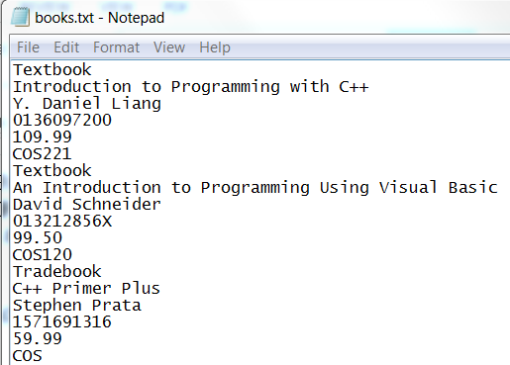

After the input section, the user is first asked for his or her major (ex. COS) and is then prompted to enter a list of courses (ex. COS225) which are stored in a String array of capacity 5. Use a sentinel-controlled loop using sentinel "xxx" to stop data entry. Assume no more than 5 courses will be entered.

Following the interactive input section, the code should display a report of book information for the student's courses as well as prices and their sum. Next a list of tradebooks and prices related to that major is displayed. Use a NumberFormat object for Currency format and align output in neat columns.

Submission:
Turn in screen shots or text file output of the two runs shown below.

